
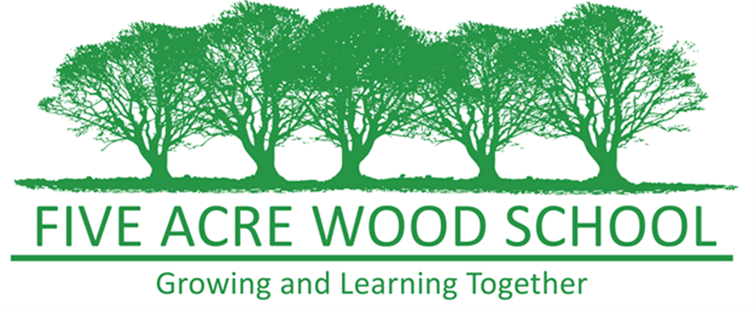

Career Education and Guidance Policy

October 2025

Article 3 – Adults must do what’s best for me

Article 12 – I have the right to be listened to, and taken seriously

Article 19 - I have the right to be protected from being hurt or badly
treated.
Article 28 – You have the right to a good quality education. You should be encouraged to go to school to the highest level you can.

Key Contact Personnel in School

Nominated Member of Leadership Staff Responsible for the policy:
Jaime Cronk
Designated Safeguarding Lead: Sarah Costain
DPO: Sarah Costain

Date written: November 2016
Date reviewed: March 2019
Date reviewed: March 2022
Date reviewed: February 2024
Date reviewed: October 2025
Date agreed and ratified by Governing Body:
Date of next review: October 2027

This policy will be reviewed following any concerns and/or updates to national and local guidance or procedure

Introduction

Career Education and Guidance at Five Acre Wood School forms an integral part of our school vision, ethos, and needs-led curriculums, which are designed to meet the diverse requirements of our pupils. High-quality careers guidance is essential for our students’ futures, supporting them to progress through education and transition confidently into the next stage of their lives. Our provision equips students with the knowledge, skills, and behaviours necessary for self-development, career management, and participation in the workplace and/or their local community.

While some students may not be able to access employment as adults due to complex needs, they will be supported to develop an understanding of the world of work. To achieve this, our careers programme aims to:

- Help students prepare for the workplace through a whole-school approach that links curriculum learning to careers.
- Provide opportunities for a variety of quality work experiences across different industries to support career planning.
- Develop students’ awareness of the range of education, training, and career opportunities available to them.
- Support students in understanding routes to careers they are interested in, enabling informed and aspirational choices for effective and sustained transitions
- Promote a culture of realistic and appropriate aspirations, ensuring that all students at Five Acre Wood School are encouraged to aim high within the context of their individual strengths, needs, and potential.
At Five Acre Wood School students will benefit from:

- Needs led classes.
- Modified curriculums and personalised learning to suit their needs.
- Motivated, trained and engaged staff with high expectations.
- Close partnership working, so that learning is holistic and is undertaken both inside and outside of school.
- Student-centred EHCP Reviews and shared goals.
- Communication strategies and augmentative equipment to enable them to express their views, wants, and needs.
- Recognised accreditation to support and evidence their progress, no matter how big or small.
- Visits to career fairs and local colleges.
- Transition support.
- Working with local employers, organisations and charities.
- Regular opportunities to engage in work-related learning or work experience either onsite or in workplace environments.

Partnerships

To achieve the above, Five Acre Wood School works in partnership with students, parents, therapy teams, local authority services, careers providers, local employers, charities, and community organisations.
Five Acre Wood School will provide:

- Activities that develop a range of attributes and resilience that will enhance student success in their education and employment.
- An environment where learning and skills can be developed through real-life tasks and contexts
- Curriculums that meet the academic and vocational needs and aspirations of our students. Regular reviews will be held to evaluate this and prepare for any new courses or changes in study programmes. This includes academic pathways to enable students to progress and work towards Level 2 or GCSE in English or/and Maths.
- Learning to support individual pathways to adulthood
- Independent career advice and guidance for students in Year 8 - Year 14. One to one interviews are provided by a registered member of The Career Development Institute following their ethos, for our students where appropriate.
- Appropriate workshops are also delivered to KS3/4 students and the majority of KS5. Employability Programmes are also undertaken with the local Department Work and Pension Team and the School works closely with its Careers Consultant as part of The Kent and Medway Careers Hub.
- Opportunities to meet with a range of providers both online and face to face.
- Educational routes and pathways suitable for the needs of the students
- High quality work experience and placements to develop vocational and professional skills in KS5.
- On site and external work-related learning for students in KS3 and KS4. This includes a local farm/s, allotments and local railway network.
- Career education that is suited to the individual needs of the students through each Curriculum model and approach.
- Engage and deliver transition activities and support for pupils moving from the main site to a satellite site and from KS5 to post 19 College, supported employment, paid employment or social care provision.
- Resources to support learning.
- Reports on the progress and destinations of School leavers.
- Information and manage applications for the 16-19 Bursary, which is available to support those students in financial hardship.
- Travel awareness training.
- Outcomes related to aspects of preparing for adulthood, employment, living skills or participation in Society will be discussed and included in EHCPs for students in Yr 9 and above.
- Signpost to Kent County Council's 'Local Offer'.
- Information on educational, technical, and vocational training opportunities available for pupils in line with the Provider Access Policy.

Statutory Requirements

This policy aligns with DfE statutory guidance (May 2025) and complies with the following legislation:
• The Education Act 1997
• The Education and Skills Act 2008
• The School Information Regulations 2008
• The Skills and Post-16 Act 2022

As a maintained school, we provide access for education and training providers to inform students in Years 8–13 about technical qualifications and apprenticeships, as required under the Provider Access Legislation.
Our CEIAG provision adheres to the 8 Gatsby Benchmarks which define ‘careers guidance’ and set expectations for quality delivery. Careers guidance covers the full range of activity under the 8 Gatsby Benchmarks.

Careers Leader
Our Careers Leader will be appropriately trained to develop and direct the Careers Programme in line with the Gatsby Benchmarks. Ongoing CPD to support the continuous development of the Careers Leader is accessed through the CEC Academy.
Our Careers Leader will:
- Embed a programme of careers education and guidance, structured around the eight Gatsby Benchmarks, that is known and understood by students, parents and carers, staff, those in governance roles, employers and other agencies. This information will be available on the school website
- Ensure that careers education is embedded within the institution’s ongoing staff development programme, including training for teachers, subject staff, and all staff who support students
- Support teaching staff to highlight the progression routes for their subject and the relevance of the knowledge and skills developed in their subject for a wide range of future pathways.
- Plan and manage the Careers Learning Journey and ensure it is progressive and responsive to leaner need
- Plan and manage a strategy for how to engage with parents and carers throughout the Future Pathways Journey
- Take responsibility for the leading, managing, co-ordinating and networking to develop the Careers Programme
- Establish and develop links with employers, learning providers and careers organisations
- Plan and manage the delivery of PAL compliant encounters to students and review our school's Provider Access Policy statement at least annually, in agreement with our Governing Board.
- Quality assure the Careers Programme, along with SLT, to ensure continuous improvement.
- Manage the budget for the Careers Provision
- Work towards the strengthened Gatsby Benchmark 6 to ensure students access multiple experiences of the workplace
- Work with the Kent & Medway Careers Hub to support continuous improvement using the free digital tools to self-evaluate.

Our teachers will:

- Proactively link curriculum content to relevant careers, regardless of whether the course is explicitly occupation focused.
- Consistently highlight how subject-specific knowledge and skills apply to a broad range of future career pathways.
- Ensure that, each academic year, every pupil in every subject receives opportunities to explore how their learning supports career readiness and workplace effectiveness.
- Embed discussions of employability and transferable skills as part of regular teaching and learning practices across the curriculum.

Our governors must ensure that:

- Independent careers guidance is provided to all learners throughout their secondary education.
- Learners in years 8 to 13 receive at least 6 encounters with a provider of technical education or apprenticeships.
Our governors will:

- Appoint a member of the governing board who will take a strategic interest in careers education and encourage employer engagement
- Undergo appropriate training via the CEC Learning Academy and other available training, such as the Governor Hub
- Oversee the development and clear communication of the school’s Careers Education, Information, Advice and Guidance and that it is clearly communicated to all stakeholders.
- Ensure independent careers guidance is provided to all learners (where appropriate) throughout their education and that the information is presented impartially.
- Monitor and uphold compliance by ensuring the school’s careers webpages are accurate, up-to-date, and meet statutory requirements

Access to Programme Information
Details of the Careers Programme are published on the school website, providing details on how students, parents, staff, and employers can access information, resources, and opportunities to support and engage with the programme.
Students, parents/carers, staff and employers can request any additional information about the Careers Programme by contacting careers@five-acre.kent.sch.uk

Monitoring and Evaluation
The school regularly reviews its Careers Programme through the School Improvement and Development Plan. This includes:
- Recording: Careers activities and events are recorded using Compass+ and students personal folders. These records are reviewed by the Careers Leader and senior staff to measure impact and support ongoing improvements.
- Stakeholder Feedback: Feedback is collected from students, parents, staff, and employers. This includes student views on their career readiness, gathered through tools like the Future Skills Questionnaire, which helps shape the future direction of the programme.
- Evaluation Against Learning Goals: The Careers Programme is reviewed each year against specific learning goals. This helps assess how well students are developing the knowledge, skills, and behaviours needed for their future pathways.
- Destination Tracking: Information about students’ intended and actual destinations is collected and analysed. This includes looking at trends in student progression, the variety and suitability of destinations, alignment with the job market, and NEET figures.
- Quality Assurance: Careers provision is regularly reviewed through internal checks such as curriculum integration, staff involvement, and student experiences. External reviews and benchmarking against frameworks like the Gatsby Benchmarks, CDI Framework, and Provider Access Legislation help ensure high standards.

Policy Review
This Policy will be reviewed on an annual basis. The factors that will be taken into account during this process will be; statutory guidance, the needs and views of our students and other stakeholders, the local offer, the service delivered by the Independent Careers Advice providers, Post 19 transition pathways, the local employment market, the availability and access to supported employment or volunteering and existing and new accreditation.

For information regarding our CEIAG and Provider Access Policy Statement, please follow the attached link;

https://www.fiveacrewood.co.uk/ceiag/

