Supporting pupils with writing difficulties and using alternative ways of recording
Alternative approaches to recording support the inclusion of students with physical disabilities in the classroom. Alongside pen and paper methods, assistive technology can level the effects of a physical disability by allowing pupils to participate in their learning more independently.
Think!
If a child has difficulties with recording their ideas, consider:
- What is the learning objective for the lesson? Think about how a pupil could demonstrate their knowledge, understanding or learning against this objective. What does the pupil need to do in order to work towards this and is writing a key part of the learning objective?
- Does the pupil need to copy the title?
- Does the pupil need to write the date?
- Does the pupil need to record the learning objective?
- Could support staff complete the above information, allowing the pupil to put their energy into the activity? If they do, ensure the pupil is engaged in the process telling the adult what the date and learning objective are.

Assistive Technology (AT) – if additional support is needed for a pupil to access assistive technology contact Kent CAT team.
- Clicker 7/DocsPlus software – computer/iPad www.cricksoft.com/uk
- Snaptype – tablet/iPad - www.snaptypeapp.com/
- Splash! - a flexible tool that enables learners with a wide range of abilities to create accurate illustrations for Maths and Science - http://www.inclusive.co.uk/splash-p6934
- Notes – iPad - http://www.callscotland.org.uk/downloads/posters-and-leaflets/making-the-most-of-notes/
- My Study Bar - http://www.callscotland.org.uk/mystudybar/
- Read and Write for Google Chrome
- One Note – Learning tools http://www.callscotland.org.uk/common-assets/cm-files/posters/raising-attainment-with-microsoft-learning-tools.pdf
- Co-writer https://cowriter.com/

Scribe / amanuensis
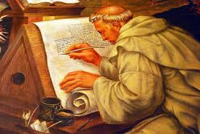
For some pupils, a scribe or amanuensis can record their learning and ideas. This could be by either writing or typing.
A scribe does not necessarily have to do all of the writing/typing – negotiate who does what. The scribe could jot down ideas at the beginning of a piece of work or throughout as pupils come up with new ideas. Some tips for developing the skills of an amanuensis are:
- always provide some visual feedback, for example, sit next to the pupil so that he or she can see what you have written or drawn for them
- annotate pupil’s work so that it is clear where help was and was not given and how the result was achieved
- allow your pupil plenty of practice in giving instructions and directions (for example underlining the date and title, using capital letters and punctuation marks)
- encourage the pupil to edit the piece of work even if its read back to them
- if the pupil is able to complete some of the work for him or herself, suggest that you start it for them, and allow them to finish so that they have a sense of achievement and completion
- try not to give factual help or ideas
- recognising that this is hard work for the pupil and they may benefit from rest breaks.
- If the scribe is handwriting, ensure the handwriting is legible for the pupil to read
Writing Frames
Writing frames are often used to scaffold pupils’ writing and they can be used so that pupils can record their key ideas in a way that demands less writing. They can be used to show pupils how to set out their writing and also to prompt them to include certain features.

Sentence starters are useful for example in practical subjects when learners are asked to evaluate a project they have taken part in, and say, or write, what they have learnt from the experience. They can be given a selection of sentence starters like: ‘I learnt that …’ ‘One thing I discovered was …’, ‘I found out that …’
Sentence frames are helpful when asking learners to organise their thoughts in a particular way, e.g. comparing and contrasting: ‘One similarity between _____ and ____ is that …’, ‘A key distinction between ________ and _________ is that …’
Writing frames can be used for pieces of extended writing, in which case learners can be given the first few words of each paragraph.
(AT) – Clicker 7 – Sentence Sets also search for writing frame resources on Learning Grids

Mind Maps
Mind maps can support learners to visualise and develop ideas, to understand and retain concepts, to plan and organise written work and to communicate and present knowledge. Mind maps can be hand drawn and software packages allow pupils to develop mind maps and then have the function to transform these ideas and links in to text to structure their work.
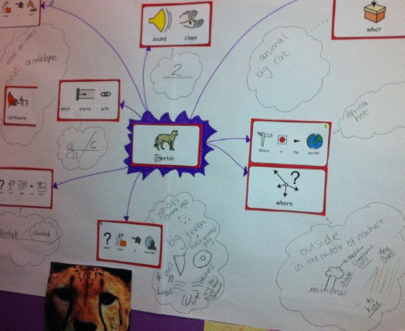
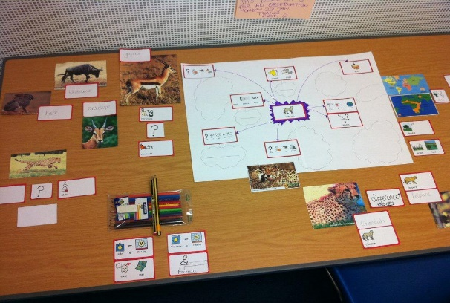

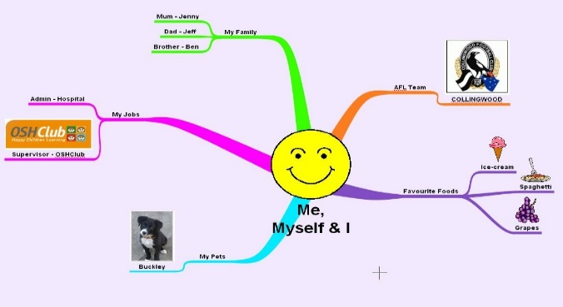
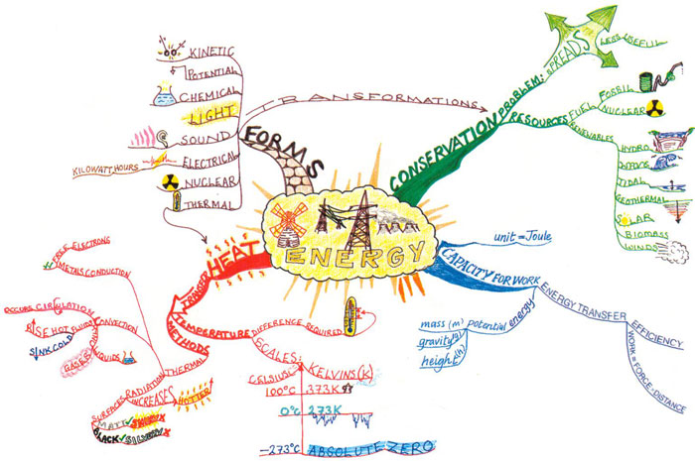

(AT) - http://www.inspiration.com/ - can get 30 day free trial
Inspiration 9 – Ages 8+ & Kidspration – Age 4 – 9
(AT) – Clicker 7, Clicker Boards – these can then be turned into word banks to support pupils writing
(AT) – My Study Bar
Spidergrams
Spider diagrams encourage pupils to jot down their thoughts without having to worry about writing in full sentences or thinking about punctuation. They are either used as a stand-alone activity to encourage pupils to externalise their thoughts and provide the teacher with an assessment opportunity, or they are used as a means of planning a 'neat' piece of writing.
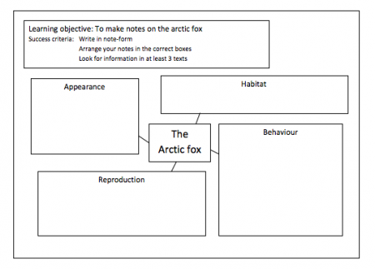
A picture or word may be put in the middle of the page and then several 'legs' drawn radiating outwards. Pupils then need to write words or phrases about the object in the centre.
A spider diagram could be used to describe a certain character. Having a picture in the centre of the diagram means that pupils have something concrete to refer to when describing the character, rather than relying on their memory.
A spider diagram could be used when researching a subject for a non-fiction piece of writing. This spider diagram prompts pupils to put different bits of information into different boxes, so that the information is already 'sorted' before they start writing it up into paragraphs.

Flow Diagrams
(AT) – Word, Smart Art Graphics

Cloze Activities

Pupils can demonstrate their learning by filling in the blanks relating to key learning points rather than writing out all of the continuous text.
Cloze refers to the ‘reading closure’ practice required when readers must fill blanks left in text, using whatever knowledge and experience they have. (Hornsby and Sukarna, 1992)
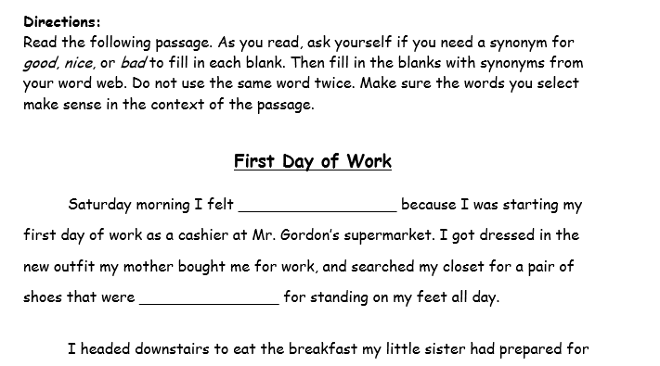
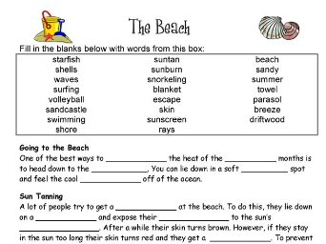

(AT) – SnapType
(AT) – PDF, edit documents and complete work sheets
(AT) – Splash!

Matching Activities
Pupils use arrows to link pictures and words.
(AT) – Clicker 7, Matching Sets – search for resources in Learning Grids
Annotating Diagrams
Give pupils handouts from PowerPoint presentations or print out screen shots from the computer or from the IWB that they can annotate.
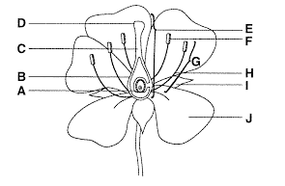
Scribe
Sticky labels lablabelsLabelse
Writing
(AT) – Clicker 7, search for labelling activities in Learning Grids
(AT) – Word – Smart Art Graphic
(AT) – Word – My Study Bar

Story Maps
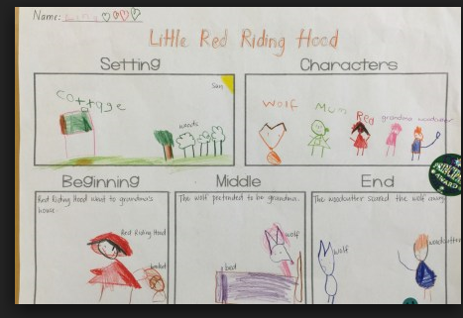
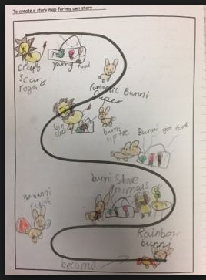

(AT) Using Clicker Board Clicker 7 to create a storyboard
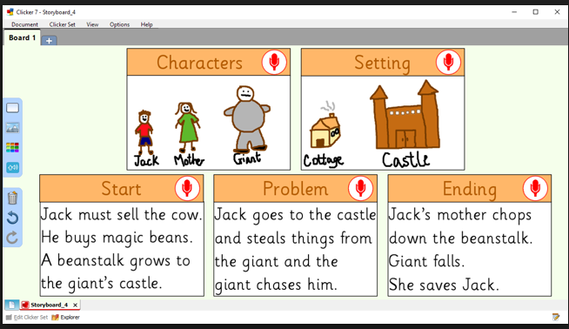

Highlighting
A pupil can highlight points in a text as a way of summarising information, organising their thoughts or demonstrating, which is the correct answer.
(AT) – highlight documents on iPad or computer

(AT) Recordable books
(AT) Clicker 7, Clicker Books

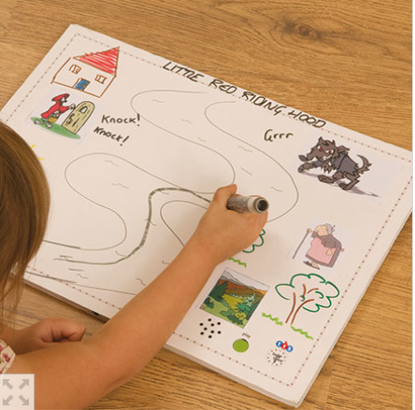
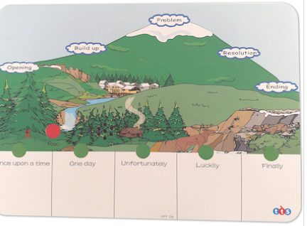

Pie Corbett's Recordable Story Mountain Recordable Postcard

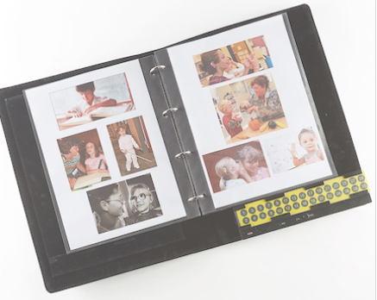
Talking Recordable Photo Album – could be used for topic work or science

Note Taking
- Scribe
- Working with peer
- Notes on iPad (see CallScotland link)

(AT) PowerPoint
Allow pupils to make a PowerPoint presentation. They can add sounds and images to enhance their work. It can support pupils with structuring their thinking using its tools to organise their work. This work can be completed collaboratively with a partner. This can also help develop speaking skills if the pupil/s share their presentation with the class. The learner will be improving their keyboard skills in the process.
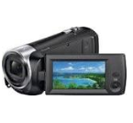
(AT) Video – using camera, phone, tablet or iPad.

(AT) Photos - using camera, phone, tablet or iPad
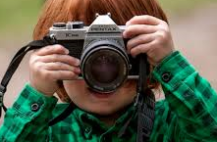
(AT) – Snaptype, use to annotate photos, use in a science experiment or to describe a picture with adjectives
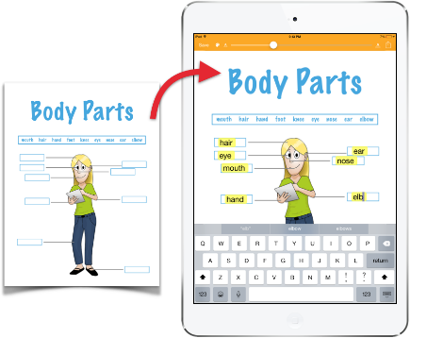
Take a picture of any worksheet using the iPad camera, or import a worksheet from email, photo library or Google Drive.

(AT) Recording speech
Pupils can record their ideas; these may or may not be transcribed at a later point. Talking tins may be suitable for younger pupils and just record one idea at a time; this may support them in retaining their ideas and responses
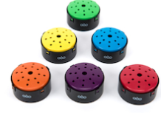
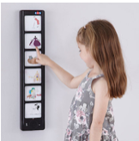
Talking Tins

- Recordable Talking Wall Panel
- Voice to text on phone, iPad, tablet or computer
- One Note – Learning tools
- Dictation button, Microsoft add on.
- Dragon speech recognition

