Transitions in the Early Years during COVID 19
Keeping children’s well-being at the centre of practice by establishing a “relationship rich” environment.

Included within this information pack:
Information | Page number
Guidance on providing a nurturing transition for Early Years children | 1-4
Ideas for supporting transitions | 5-7
The PACE approach to supporting children with anxiety and trauma  (can be printed as a poster) | 8
An aide-memoire for staff – reflective questions linked to transition  (can be printed as a poster) | 9
Signposting to additional resources/information | 10
A transition checklist (to be used during the Covid 19 period) | 11-12

Thank you to Amy Root, Gemma Rayner, Jo Hughes, Katie Holmes and Katy Keeler for their thoughts and reflections.

A nurturing approach to transitioning back into Early Years settings
(Adapted from support and guidance produced by the Thanet Inclusion Team)
It is through the setting community that we can embrace our children in the safe and consistent place that will nurture and begin to create normality again. The children most severely impacted by the pandemic will not find it easy to ‘settle to learn’ (Bomber, 2013) and as we know they will communicate this to us through their behaviours. We know that chronic stress disrupts the nervous system however old we are and impacts everything that we do.

What might we see?
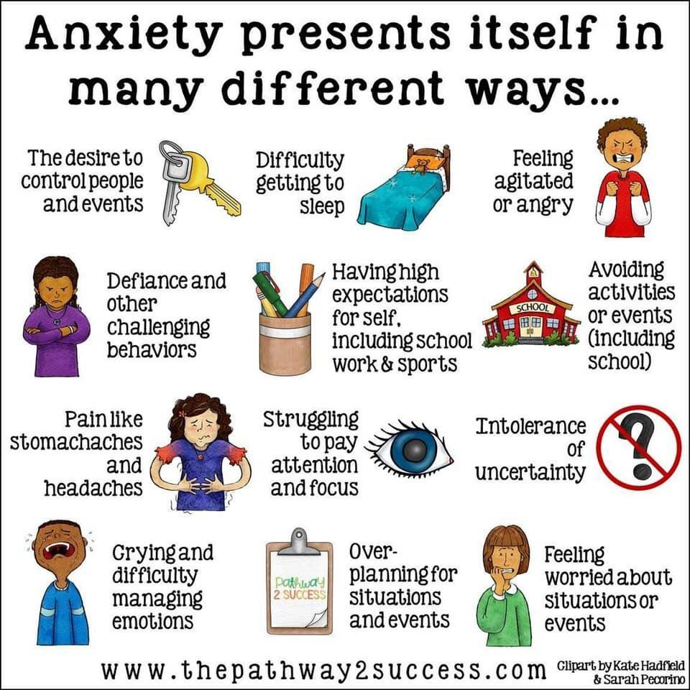
- children who are jumpy, tearful, angry, hyper-vigilant; still operating in survival mode and easily triggered into flight or fight reactions.
- children who are excessively quiet, dazed or tuned-out and whose reaction is to freeze or to dissociate. They will retreat from a frightening and unpredictable outside world into one within the mind that feels safer.
- children who are showing elements of regression, e.g. having frequent accidents and start wetting themselves.
- children who appear to be fearful of adults/others, averting their gaze for example or require additional support to part from their families and settle in a setting/school.

It is important to remember that the impact of the current situation effects children and adults to varying degrees. There will also be some children who will show no or truly little change to their well-being, interactions and demeanour.
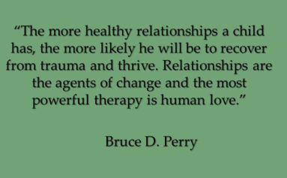
What can we do?

Make relationships the scaffolding of everything that will come next.
The good news is that anyone can help with this part of “therapy” – it merely requires being present in social setting and being, well, basically, kind…. The more we can provide each other these moments of simple, human connection – even a brief nod or moment of eye-contact – the more we will be able to help heal those who have suffered traumatic experience. (From “The Boy who was Raised as a Dog” – Dr B Perry)
- Relationships between all members of the early year’s community should be a deliberate strategy and not a by-product or something that is left to chance.
- ‘Every interaction is an intervention.’ (Dr. Karen Treisman) and although it may be tempting to plan and organise interventions, this information should form the basis of all that happens as we return. Sharing experiences from home and providing a range of opportunities for talk to encourage the child’s voice to be heard.
- Engage the children in discussions about the support and comfort that they would like/can be given whilst regarding guidance around social distancing etc.
- Information sharing between adults is crucially important, so far as confidentially allows it, the emotional climate of a setting will change daily, and the needs of individuals will change just as often. Continuing to build and re-establish relationships with children through positive experiences will support children to feel safe within the environment, as well as planning activities and interactions following the child’s interests.

Be a listening early years provision

Everyone in the setting will be reassured by understanding that the community they are entering into is a listening one. Anxiety levels may be unusually high for everyone – including parents – and to address this there will need to be a consistent and authentic message that the anxiety is understood and understandable and that support is genuinely available so that everyone can begin to relax into some sort of normality together again. That there is no expectation or aim for it to be business as usual.

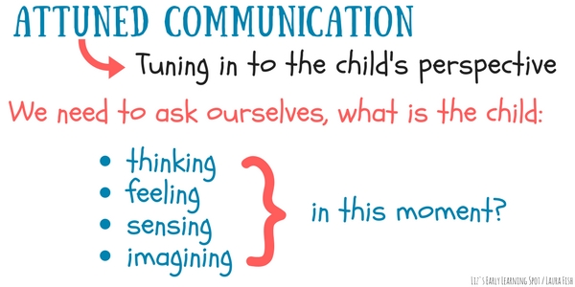

- Daily greetings, adapting settling in times, worry boxes, whole setting well-being assessments, social meal and snack times, open-door policies / text messaging (as far as this is possible) and the sharing positive events and situations will continue to be of immeasurable importance and all these strategies and are worth introducing if they are not already in place.
- Flexibility around the delivery of the Early Years Foundation Stage curriculum and the consistent implementation of visual timetables will be so important. Familiar adults who listen with empathy and without feeling the pressure of fast paced activities will support the rebuilding of trust and the making sense of experiences. Some children may be carrying enormous emotional burdens and the setting might be their only place for talking about these. By creating and respecting opportunities for children who need them, we are avoiding blocked grief and this in turn will avoid dysregulated behaviours and ultimately mental illness.

Boundaries, rules and routines

A nurturing approach that puts well-being and flexibility at its heart does not mean an absence of routine and / or rules. Research clearly states that children need clear boundaries to feel psychologically as well as physically safe and secure. The importance of these will need to be emphasised and consistently applied.

- It may be useful to consider all children as new starters.
- Routines will need to be simple, explicit and consistent. Reteaching routines using verbal and very visual prompts and reminders will create a sense of safety and order and support children to lower their guard and take control of their thinking. Children who feel chaotic will be acting from their limbic brain and will therefore be in a constant state of fight or flight and not able to engage in any rational or problem solving thinking due to their hyper-vigilance.
- Carefully think about the structure of the day; making it as fun, safe, nurturing and enjoyable as possible for the children. Consider the balance of play, child initiated and adult led times in line with hygienic practise whilst being reflective of the routine the children knew prior to Covid-19.
- Coming back to the setting may be frightening for children and parents who have internalised the message that people outside the home are a threat to life. Validating these feelings and showing understanding will be essential to making everyone feel calm and safe as well as facilitating the frontal cortex part of their brain to re-engage, enabling them to be part of the setting/school community.
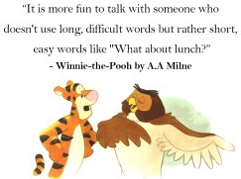
- Rules should be expressed positively and explained to the whole cohort of children. New, Covid-related rules should be stated in simple, key word language and illustrated visually. Social stories can be written to support these as needed. Messages around rules should be communicated with kindness and patience and ideally not as a basis for an action and consequence discussion but as another tool to make children feel safe and secure within their environment. This in turn will help parents to feel reassured that they know what is expected in the setting.
- Wherever possible share with families how the setting will be/is different, how it will look, what the expectations of parents and children will be so that everyone knows about this as soon as possible and this can be talked about, in advance at home.

Remember that by “not talking about it” doesn’t mean it didn’t happen!

It will, of course, be especially important to tread carefully and not trigger the children to be re-traumatised about the virus, but there is very strong research that supports a community coming together for organised reflection and collective meaning-making.

Some ways of remembering this positively could be:
- Clapping for carers - children may well have done this with their parents at home. This may provide a link between home and the setting and a sense of familiarity.
- Sharing, recreating and celebrating children’s achievements and creations and their recent positive experiences (e.g. making rainbows) e.g. on displays, websites etc.
- Some children may have lost family members and all children will have experienced loss in a wider sense. It is important that bereavement is not a subject that is too difficult to talk about for the children. They will need opportunities to do this but also to have in the moment support. There is further advice about supporting bereaved young children in the “Small Steps” document (see additional resources.)

Valuing Staff

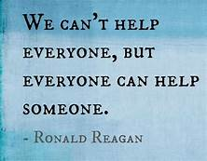
Adults within the setting will need support and confirmation to understand the difference they can make, through simple connections. It is likely to be an anxious time for adults feeling that they are not doing enough and that they are not equipped to deal with the trauma that children may have experienced or that they or their colleagues may have experienced themselves. Knowing that the small things they do and say are the most powerful, in supporting healing and immeasurable, in making a difference, they will give confidence and reassurance that everyone is on the same page and on the same journey together.

Supporting children’s transitions within Early Years Settings

Considerations for children at home; the current setting/school could consider
- Providing parents with the child’s most recent summative assessment of their child’s learning and development. Make suggestions as to how they can support any skills their child was on the cusp of mastering, or that they may need a little more support with.
- Create an online album of photographs you have taken with the children and share with families so that children can look through them with their families – utilising online record keeping/assessment platforms e.g. Tapestry etc. – encouraging parents to share the same with you.
- Share some activity ideas with parents – think of things that you may have usually done in your setting that they can recreate easily at home if they choose to.
- Sharing stories and experiences online and maintaining contact with children and families via phone/video call/letters etc.
Considerations for children returning to a setting/school
- Liaising with families as to how COVID 19 has affected them, e.g. at home, relationships, illness and sadly if any deaths have occurred.
- Liaising with parents about their child’s interests and experiences during their time at home e.g. favourite books/stories/songs/toys/activities and using these to inform your provision planning.
- Sharing photographs of the child’s current setting/school to remember what they may be returning to, e.g. the staff/environment/activities etc.
- Messages to “catch up” with children and parents/carers (conveying welcoming messages and messages that children and families are being thought about.)
- Are forums available for children and families to share their “lockdown experiences” with staff before they return and when then return and for these to begin to build memories and shared experiences.
- Providing Social stories for children to explain the situation and to support their understanding of expectations.
- Sharing of expected daily routines and experiences with children and parents to help them prepare for their return.
- Sharing stories between children and staff through social media/virtually.
- Seek permissions from parents for settings/schools to share important transition information with receiving schools/settings.
- With parental permission, liaise with professional/agencies involved with the child and family to share information pertinent to the child and to support transition planning, e.g. Specialist Teacher, Children’s Therapy Staff, Early Help, Social Care etc.
- Share advice and “top tips” information with parents where necessary, e.g. NHS Trust advice leaflets.
For children to gain a positive view of school and feel confident they need:
- a good knowledge of the layout of the room and some knowledge of the setting building
- a knowledge of the practitioners and the way they think
- an understanding of the language and communication used in the setting
- an idea of the nature of the activities that take place
- strategies to make friends
- a sense of the setting culture (adapted from Fabian and Dunlop, 2015, p. 181)
Considerations when planning for children transitioning to a setting/school
- Liaising with families as to how COVID 19 has affected them, e.g. at home, relationships, illness and sadly if any deaths have occurred.
- Liaising with parents about their child’s interests and experiences during their time at home e.g. favourite books/stories/songs/toys/activities and using these to inform your provision planning - celebrating positive experiences and acknowledging difficulties that may have been experienced.
- If you have a setting/school website can a section be dedicated to transition/new starters to include relevant information and some of the following? Or can information packs be sent/delivered for those without access to these resources.
- Video tours of environments – showing external and internal spaces including areas that routines will occur in, e.g. when entering or leaving, lunch times, toileting, playing, learning, where personal belongings will be kept etc.
- Sharing photographs of the child’s new setting/school, class environment, staff, uniform etc.
- Personalised transition planning, e.g. where a highly supportive transition would be beneficial, that they can visit the setting/school with a parent (adhering to social distancing requirements) when there are no other children present? The child/parent could film/take photos of the experience to talk about and discuss at home.
- Messages to introduce staff to children and parents/carers.
- Are forums available for children and families to share their “lockdown experiences” with staff before they return and when then return and for these to begin to build memories and shared experiences.
- Virtual welcome events online for parents and opportunities for parents to “send in” questions and find out answers to questions/queries/concerns.
- Virtual meet the staff/teacher events and for parents to link up with other parents.
- Social stories for children to explain the situation and to support their understanding of expectations.
- Sharing of expected daily routines and expectations to help children prepare for them.
- Sharing stories between children and staff through social media/virtually.
- The idea of a “lockdown library” for children to visit settings/schools to borrow books whilst becoming familiar with entering the school gates
- Allow children opportunities to ask questions, share information and express thoughts and emotions about the situation.
- Seek permissions from parents for settings/schools to share important transition information with receiving schools/settings.
- With parental permission, liaise with professional/agencies involved with the child and family to share information pertinent to the child and to support transition planning, e.g. Specialist Teacher, Children’s Therapy Staff, Early Help, Social Care etc.
- Share advice and “top tips” information with parents where necessary, e.g. NHS Trust advice leaflets.
- Can parents and children engage in simple challenges set by staff e.g. “can you dress yourself?” or “catch me sharing a book with a family member” that are shared with staff.
Considerations for when children are in the setting/school
- Continuous liaison with parents – this may be via phone, email, online learning platforms etc.
- Planning should be led by the children’s stage of development rather than the children’s chronological age to build upon what they have experienced, know and understand, taking in to account possible difficulties or regression due to the current situation.
- Providing an effective and appropriate environment that includes starting points/prompts for talking about things they will have seen/heard – role play doctors/nurses/images of rainbows/opportunities to draw & paint/express themselves and possibly their thoughts.
- Consistent implementation of visual supports, e.g. visual timetables – there may be large group versions and individual ones depending on the needs of the child.
- Clear, consistent routines that are actively and regularly communicated to children (verbally and supported with visuals.) Children will benefit from effective warnings of transitional times throughout the day, using a “now and next” approach supported by resources, e.g. sand timers.
- Using the children’s interests, experiences and stages of development as starting points (utilising information gained from parents and previous settings.)
- Making sure staff are providing plenty of time to play alongside children so can capture any questions or conversations that spontaneously arise, also building those key relationships.
- The use of the Leuven Well-Being and Involvement Levels or a rating system looking at the Prime Areas of learning to monitor children’s well-being would be beneficial.
- Provide on-going opportunities for the development of children’s independence and self-help skills e.g. dressing/undressing/managing lunch boxes etc.
- Plan for staff to spend time modelling social interactions and conflict resolution with children, teaching and reinforcing PSED skills within play and routine situations.
- Be aware of the signs of emotional unrest and trauma in young children and how to support these.
- Provide low arousal activities, calming resources, e.g. calming boxes, and quiet areas.
(Ideas for calming boxes: bubbles, small wind-up toys, fidget toys, small sorting activities.)
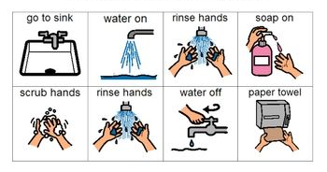
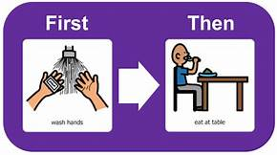
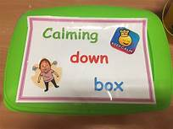
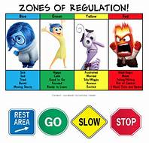
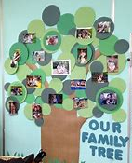

The PACE approach (not linked to any KCC initiative)
The PACE approach was developed by Clinical Psychologist Daniel Hughes to support the open communication and emotional awareness of children who have experienced trauma through positive interactions and the development of connections with parents and carers and other key adults.

Playfulness
Using a light-hearted, reassuring tone - similar to parent-infant interactions - to create an atmosphere of safety and reassurance where no one feels judged and children feel able to cope with positive feelings

Acceptance
Acceptance is about actively communicating that the feelings, thoughts and internal struggles that are underneath the child's outward behaviour are accepted. It is not about accepting the behaviour itself but helping to teach the child to not feel ashamed by their inner turmoil.

Curiosity
Curiosity, without judgement, is how we help children become aware of their inner life. It is about wondering out loud without necessarily expecting an answer in return. Phrases like "I wonder if..." will help the child to put a name to their emotions and thoughts.

Empathy
Feeling a child's sadness or distress with them, being emotionally available to them during times of difficulty shows the child that they are not alone and that the adults are strong enough to support them both through it. (Nottinghamshire County Council - https://www.nottinghamshire.gov.uk/fanotts/parenting/pace )
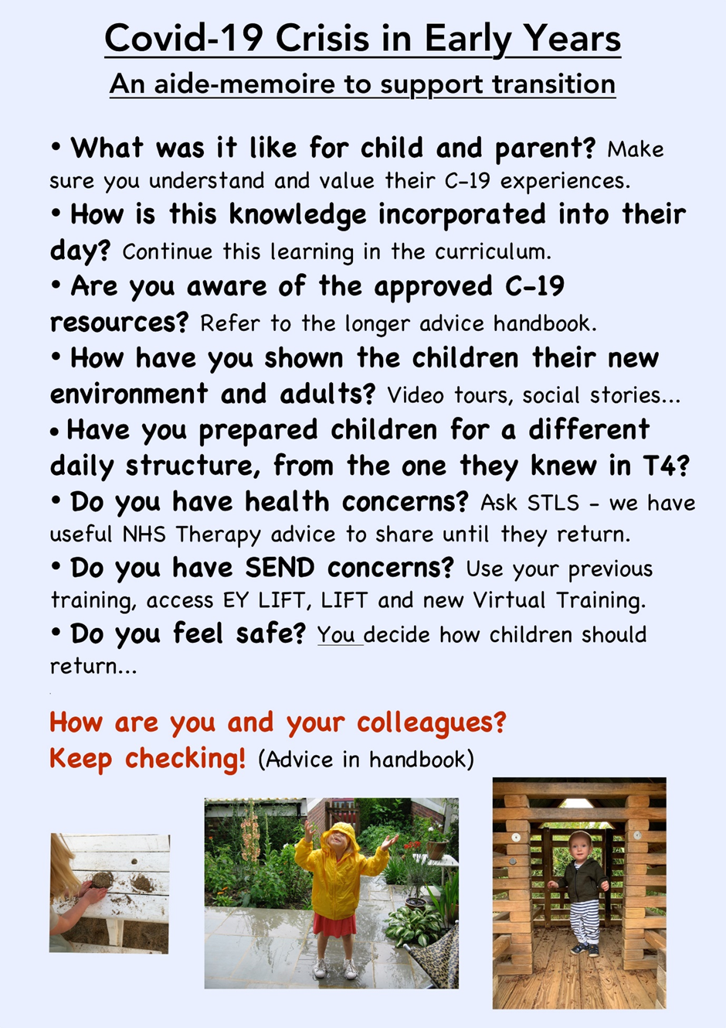
Additional support and useful information
Specialist Teachers are working with Early Years settings and schools to support children on their caseloads during this period of transition and can be contacted for further advice and support. For information on Early Years/School Age LIFT referrals/meetings etc. please contact your District Specialist Teaching and Learning Service Team.

During this time, the Early years and Childcare Equality and Inclusion team are still available to support you with meeting the needs of all your children, via telephone. Please follow the link to our request for support form:
https://kentcc-self.achieveservice.com/service/Equality_and_Inclusion_Request_for_Support_form_Process

SENIF Practitioners continue to work in liaison with the Early Years Specialist Teachers to support transition and create resources as appropriate. They are also available to join transition meetings for the children that they have supported throughout this year.

Useful Websites, articles, webinars | Internet Link
Maureen Hunt’s Webinar (via Kinderley Learn) on Transitions: Supporting young children after Covid 19 | https://www.youtube.com/watch?v=UCsf4IIn4qY
Webpage: Coronavirus: Supporting Transition into Reception – ideas and approaches to consider as well as resources to download | https://schoolleaders.thekeysupport.com/covid-19/safeguard-and-support-pupils/pupil-wellbeing-and-mental-health/coronavirus-supporting-transition-into-reception/
The Education People’s Small Steps Publication is available as a free download - Small steps is a support guide for pre-school settings to help a child with their first steps in their grieving journey.
See additional documents
The Education People’s Transition Matters Document is available as a free download
See additional documents
ABC Does Blog provides ideas and discussion around transition and continuous provision in Year 1 | https://abcdoes.com/abc-does-a-blog/category/transition/
Introduction to Adverse Childhood Experiences – Early Trauma Online Training (Free) | https://www.acesonlinelearning.com/
Children’s guide to coronavirus | https://www.childrenscommissioner.gov.uk/wp-content/uploads/2020/03/cco-childrens-guide-to-coronavirus.pdf
Working with COVID-19- Containment and reciprocity when working with families. | https://solihullapproachparenting.com/working-with-covid/
The Education People Poster - Coronavirus Supporting children’s transitions | https://www.kelsi.org.uk/__data/assets/pdf_file/0003/106581/TEP-Coronavirus-Supporting-Childrens-Transitions.pdf
Information and advice for parents and professionals working with young children. Coronavirus: From the perspective of a baby or young child. | https://www.annafreud.org/coronavirus-support/support-for-early-years/

Useful Websites for Parents
https://www.earlyyearseducator.co.uk/practical/article/parent-school-talk
https://www.tts-group.co.uk/blog/2016/02/17/9-top-tips-for-managing-transition-from-nursery-to-school.html
https://www.pacey.org.uk/partnerships/starting-school-together/preparation/
https://www.bbc.co.uk/cbeebies/grownups/how-to-prepare-your-child-for-primary-school
https://www.nhsggc.org.uk/media/257792/getting-ready-for-school-or-nursery-information-sheet.pdf
https://www.nhs.uk/live-well/sleep-and-tiredness/healthy-sleep-tips-for-children/?tabname=childrens-sleep

Early Years Setting to Primary School SEN/AEN transition checklist (adapted due to Covid 19)
Child’s name: DoB:
Setting: Receiving school:
Transition planning actions and recommendations |  | To be led by |  | Record date when actioned and by whom | Notes or further actions
 |  | EY setting | School
Term 5/6 | Contact with the child’s receiving school once parents have accepted their school place to initiate sharing of information – with parental consent and keep parents informed
Term 5/6 | Complete EY Transition Documents (with support of professionals involved as appropriate with parental permission) |  |  |  | Professionals to support the sharing of information if able to
Term 5/6 | Share information gathered about the child and transition document with receiving school (with parental permission) including safeguarding information - a phone call/video conference call would be beneficial to support the sharing of information.
Term 6 | Arrange a virtual transition meeting if felt appropriate (those to attend may include parents, relevant staff from school and setting and professionals)  A supportive transition package may be planned.
Term 5/6 | School staff to consider:  - Relevant training that may need to be accessed  - Specialist resources or equipment required  - Staffing requirements e.g. additional staff, organisation of classes and staff etc.  - The physical environment and any adaptations to be made  - The need for an individual healthcare plan  - If risk assessments are required  - If a PEEP is required  - If an EY PEP is required  - Specifications in EHCP (if the child has one)  - Applying for High Needs Funding  - Possible support for the family | Share info with the school

Early Years Setting to Primary School SEN/AEN transition checklist (adapted for the Covid 19 period)
Child’s name: DoB:
Term 6 | Put in place enhanced personalised transition e.g. additional visits for the child to the school out of hours – adhering to social distancing guidelines, regular contact with the family, key school staff to establish links with family, e.g. FLO, etc. – EY setting to support if able/appropriate
Term 6 | Provide transitional support resources e.g. social stories, photo books/packs, videos etc. and share with families and feeder settings
Term 6/1 | Carry out home visits conversations via phone call/video conference
Term 6/ 1 | Consider, discuss and arrange a personalised settling in timetable for September with parents  (if appropriate)
Term 6/1 | Relevant information shared with staff on a need to know basis
Term 6/1 | Gather evidence and apply for High Needs Funding (HNF) if appropriate
Term 1 | Follow-up with EY setting to ensure all information has been shared
Term 6/1 | Relevant information shared with staff
Term 1 | Strategies, Outcomes and Targets to implemented from reports from professionals – e.g. putting a personalised visual timetable in place. Continue to liaise with these professionals
Term 1/2 | On-going: Continue to liaise with parents/carers and staff to review the transition into school and reflect on flexibility and adaptations to meet the child’s needs
Signed by Setting SENCo: Name: Date:

School SENCo/EY Staff member: Name: Date:
EY Settings can pass a copy of this checklist on to the receiving school with the child’s developmental information as part of the transition process or settings/schools can use as they see fit.
The checklist is not intended to be exhaustive and as a working document can be modified or added to by settings/schools to include the setting’s/school’s own good practice. The order of some of the events is suggestive - these can be changed or adapted to fit in with your own policy. It is important to note that the timeframes have been adapted due to the Covid 19 situation.

